**St. Francis Institute of Technology Borivali (West), Mumbai-400103**

**(Autonomous Institute)**

**Department of Information Technology**

**Academic Year: 2024-25**

**Class: TE-ITA/B                                                                            Semester: VI**

**Subject: Web Lab**

**Experiment –9: To Design a Weather App using Flask.**

1. **Aim:** To design an app using Flask Framework.
2. **Objectives:** Aim of this experiment is that, the students will be able

* To install Flask Framework
* To understand Basics of Flask.
* To understand Flask Application

1. **Outcomes:** After study of this experiment, the students will be able

* To build applications.
* To build URL
* To understand HTTP methods.

1. **Prerequisite:** Basic understanding of HTML and Python etc
2. **Requirements:** Personal Computer, Windows operating system, VSCode, Python 2.6 or higher, browser, Internet Connection, google doc, latest version of Python.
3. **Pre-Experiment Exercise:**

**Brief Theory:** Refer shared material

1. **Laboratory Exercise**
   * + 1. **Procedure:**

[Install](https://www.python.org/downloads/) [Python 3](https://www.digitalocean.com/community/tutorials/how-to-install-python-3-and-set-up-a-local-programming-environment-on-windows-10) on local machine

Set up a programming environment via the command line

Installactivate Python environment

Install Flask using the [pip](https://pypi.org/project/pip/) package installer

**a. Answer the following:**

## Flask Variables and rules?

ANS:

1. Flask variables in routes allow dynamic URLs by using <variable_name> syntax.
2. Variables are defined inside route decorators, e.g., @app.route('/user/<username>').
3. The value passed in the URL is captured and passed as an argument to the route function.
4. Flask supports type converters like <int:id>, <float:price>, <path:subpath>.
5. Default type is string if no converter is specified.
6. Flask automatically handles URL mapping based on defined rules.
7. Variable rules help make RESTful APIs (e.g., /products/<int:id>).
8. url_for() uses these rules to generate dynamic URLs.
9. If a route doesn't match the rule or variable type, Flask returns a 404 error.

## Flask session?

1. ANS: Flask session is used to store data across requests from the same user.
2. It behaves like a dictionary and is used to store temporary data (e.g., login info).
3. Flask uses **secure cookies** to store session data on the client-side.
4. You need to set a SECRET_KEY in your app for session security.
5. Example: session['username'] = 'john' stores data; session.pop('username') removes it.
6. Data stored in session is automatically encrypted using the SECRET_KEY.
7. Sessions persist until the browser is closed or manually cleared
8. Useful for authentication, preferences, or tracking user behavior.
9. Flask’s session system is built on top of werkzeug's secure cookie system.  
   Extensions like **Flask-Session** can store sessions on the server instead of cookies (e.g., Redis, Filesystem).

**b**. **Attach screenshots:**

* Flask SS

1. **Post-Experiments Exercise**
2. **Extended Theory:**

Nil

1. **Questions:**

### Flask applications?

1. **Conclusion:**

* Write what was performed in the experiment.
* Write the significance of the topic studied in the experiment.

1. **References:**

# Flask Web Development[,](https://freepdf-books.com/beginning-javascript-with-dom-scripting-and-ajax-2nd-edition-pdf-free-download/) by Miguel Grinberg

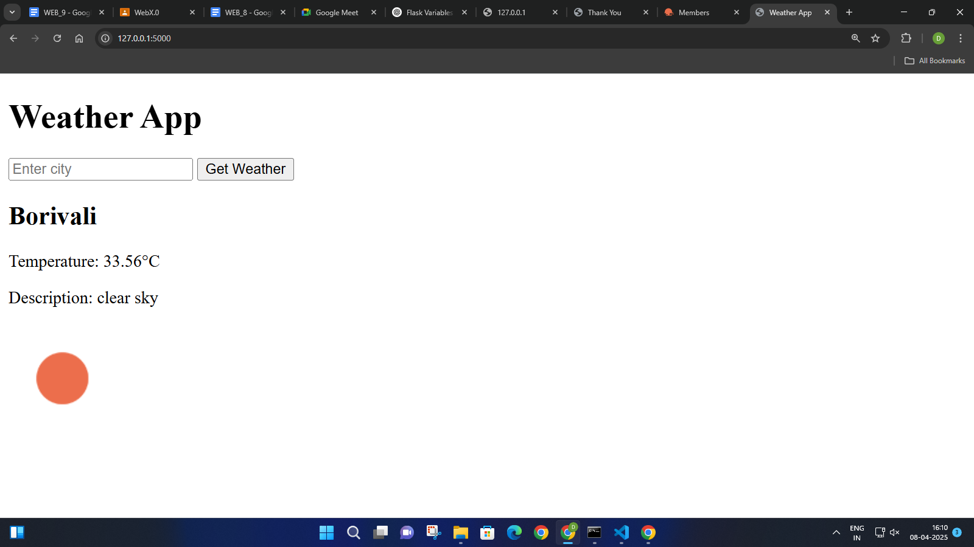

This is the output where we can enter any city and fetch its temperature and description through the api using Flask and Python.